Freelance profile  
We have half of the registered freelancers who have not completed their profile, which is a significant loss of potential subscription.  
**1-Freelance profil home**  
1-1-On the freelance profile, you must add a banner type boostrap alert-alert-danger banner with the text in white and red background, with a warning icon to the left of the text.  
1-2-The banner is to be added to the home page of the profile, see screenshot below. The banner must be above the logo and the edit profile button from left to right.  
The text in French must be: Votre profil n’est pas complet, pour être visible dans l’annuaire des freelances et être contacté par des clients, vous devez terminer de remplir votre profil en cliquant sur le bouton « Modifier »  
(Make a link on "Modify" which opens the profile modification form.)

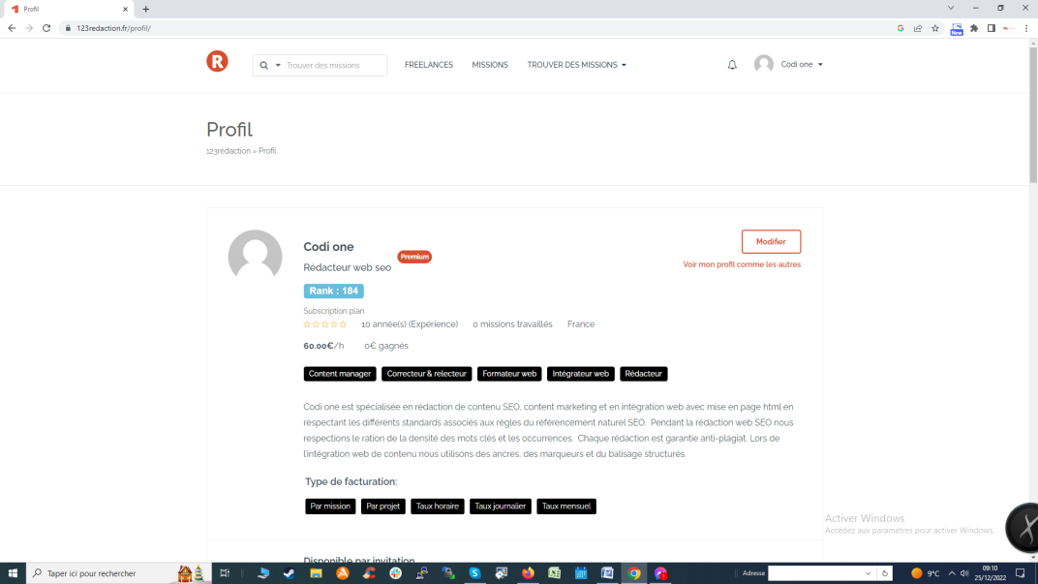

**2-Freelance profil update**

2-1-On the freelance profile, you must add a banner type boostrap alert-alert-danger banner with the text in white and red background, with a warning icon to the left of the text.

2-2- The banner is to be added to the page update of the profile, see screenshot below. The banner must be above the logo.  
  
The text in French must be: Votre profil n’est pas complet, pour être visible dans l’annuaire des freelances et être contacté par des clients, vous devez terminer de remplir votre profil en renseignant les champs ci-dessous avec un encadré rouge.  
  
2-3-If mandatory fields are not filled in, you must change the color of the border of the field to red.

